# Developer details

* **Name:** Tsotetsi Moeketsi
* **Course:** Full Stack Java Developer
* **Phase:** One
* **Project link:**

# Sprint details

## Sprint one

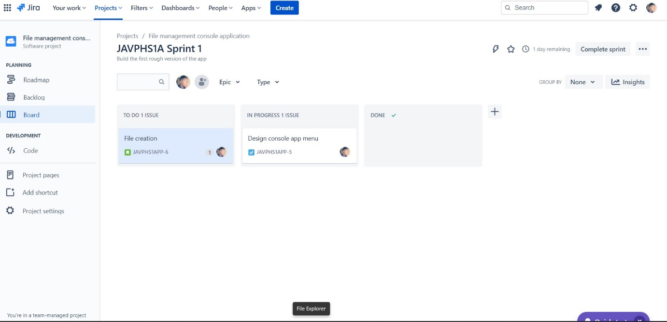

## Sprint two

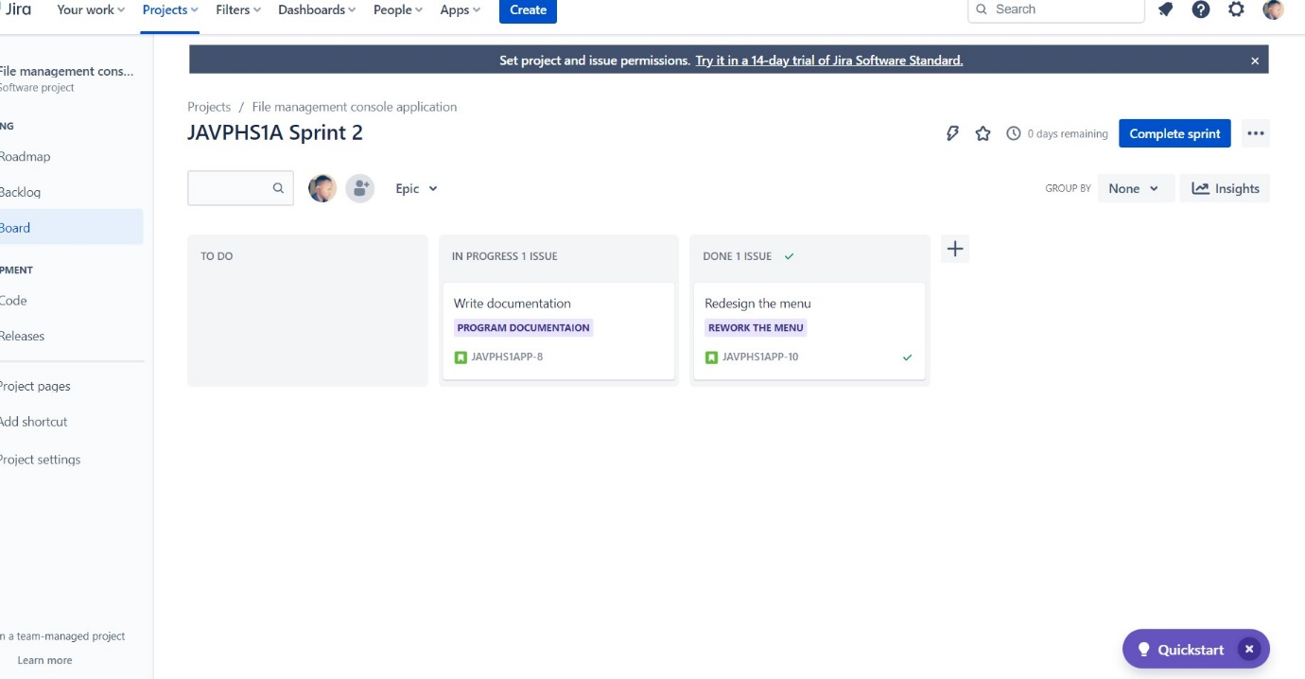

## Core concepts used

* Encapsulation
* Polymorphism
* Data structures